## **📌 Overview: Web Application for User Authentication**

This web application provides a **secure authentication system** that includes three main functionalities:  
🔹 **User Registration**🔹 **User Login**🔹 **Password Recovery (Forgot Password)**

It is built using **Streamlit** and integrates with **SQLite** for database management. User credentials are securely stored using **bcrypt hashing**. Additionally, the system implements **OTP (One-Time Password) authentication via email** for added security.

## **📌 Feature 1: User Registration🔹 Functionality**

* Users can create a new account by providing:
  + **Username** (Must be unique)
  + **Email** (Used for verification & password recovery)
  + **Password** (Securely hashed using bcrypt)
* When the **"Register"** button is clicked:
  + The system **validates input fields** to ensure they are not empty.
  + It **checks if the username or email already exists** in the database.
  + If valid, the new user account is **stored securely in the SQLite database**.
  + If the username or email is **already taken**, an error message is displayed.

### **🔹 Expected Outcome**

✅ Successful registration shows **a confirmation message**.  
🚫 Errors are displayed if the user already exists or fields are missing.

## **📌 Feature 2: User Login**

## **🔹 Functionality**

* Users can log in by entering:
  + **Username**
  + **Password**
* When the **"Login"** button is clicked:
  + The system **verifies if the username exists** in the database.
  + It **checks if the entered password matches** the stored (hashed) password.
  + If the credentials are correct:
    - An **OTP is generated and sent to the registered email**.
    - The system **prompts the user to enter the OTP** for verification.
  + If the credentials are incorrect, an error message is displayed.

### **🔹 Expected Outcome**

✅ If correct, the user **receives an OTP** and must verify it.  
🚫 If incorrect, the system shows **"Incorrect username or password"**.

## **📌 Feature 3: Forgot Password (Password Recovery)**

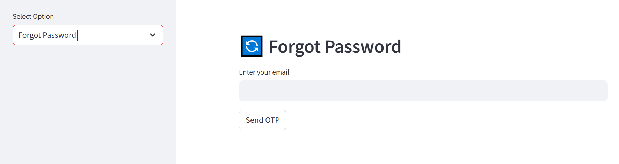

### **🔹 Functionality**

* If a user forgets their password, they can reset it by:
  + **Entering their registered email**.
  + Clicking the **"Send OTP"** button.
* The system then:
  + **Verifies if the email exists** in the database.
  + **Generates an OTP** and sends it to the user's email.
  + Prompts the user to **enter the OTP** and **set a new password**.

### **🔹 Expected Outcome**

✅ If the OTP is correct, the user **can reset their password successfully**.  
🚫 If the email is not found, the system shows **"Email not registered"**.